Sequence Node

Use the Sequence node to add a sequence number to one or more groups of input messages.

Purpose:

The Sequence node enables you to receive groups of messages from an input source, and preserve the order in which the messages in each group arrived.

Use a Sequence node to generate a monotonically increasing sequence number for each sequence group. As each message in the group arrives at the Sequence node, the sequence number for the group is incremented and stored with the message in a location specified by the node property Path to store sequence number (for example, LocalEnvironment, MQRFH2 header, message body).

1. Click on "File" tab and select "New"=>"Application".

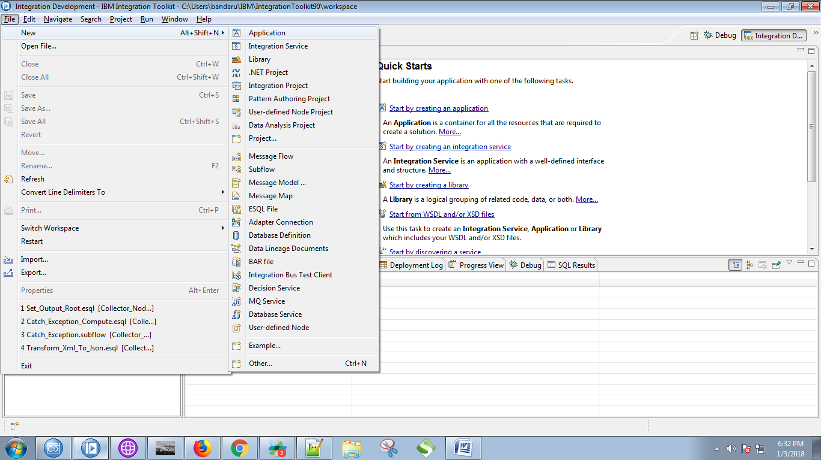

2. Give a name for your application and click on "Finish" button.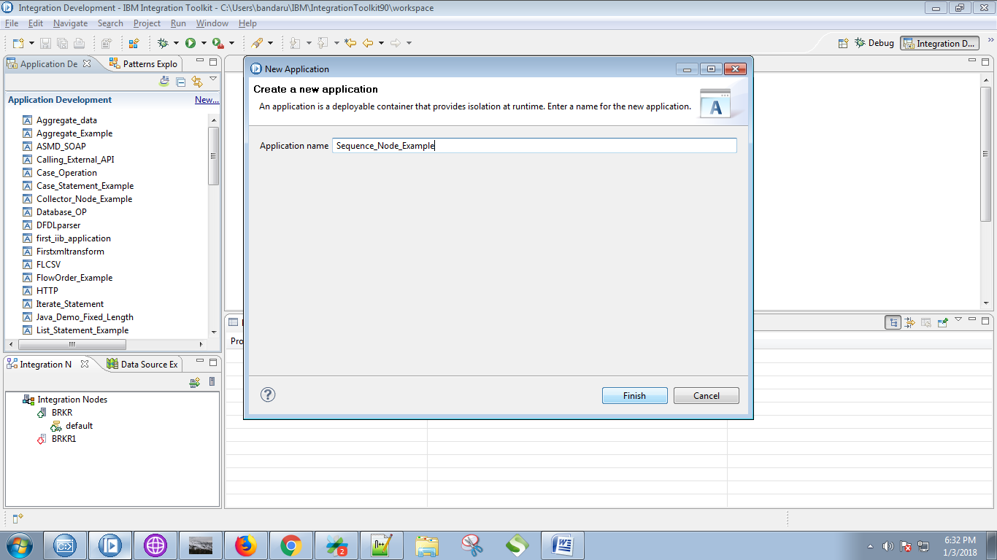

3. Under your application you can see "New" option, Click on it.

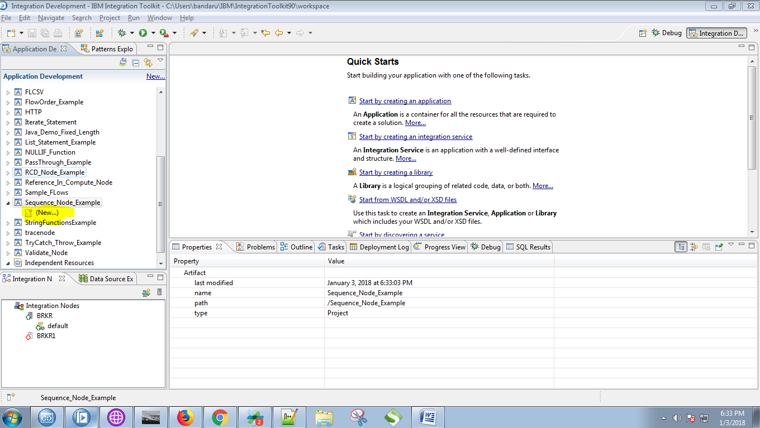

4. Select "Message Flow" from the given options.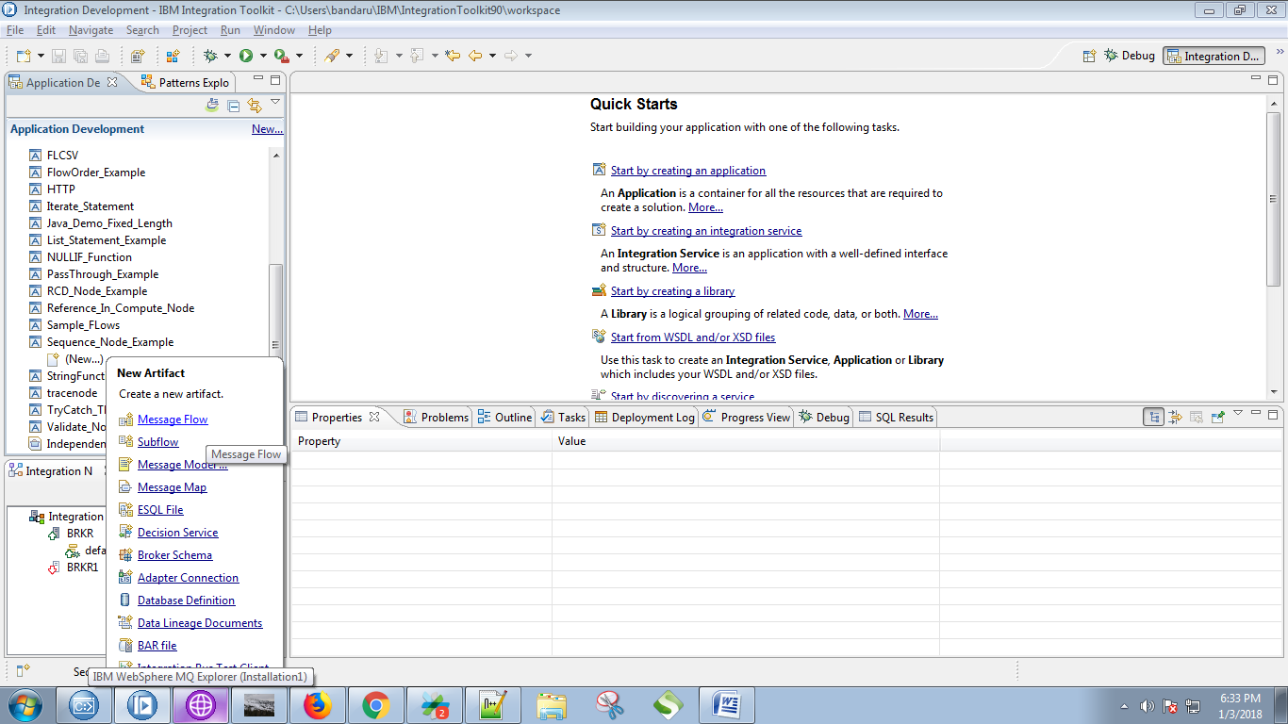

5. Give a name for your message flow and click on "Finish" button.

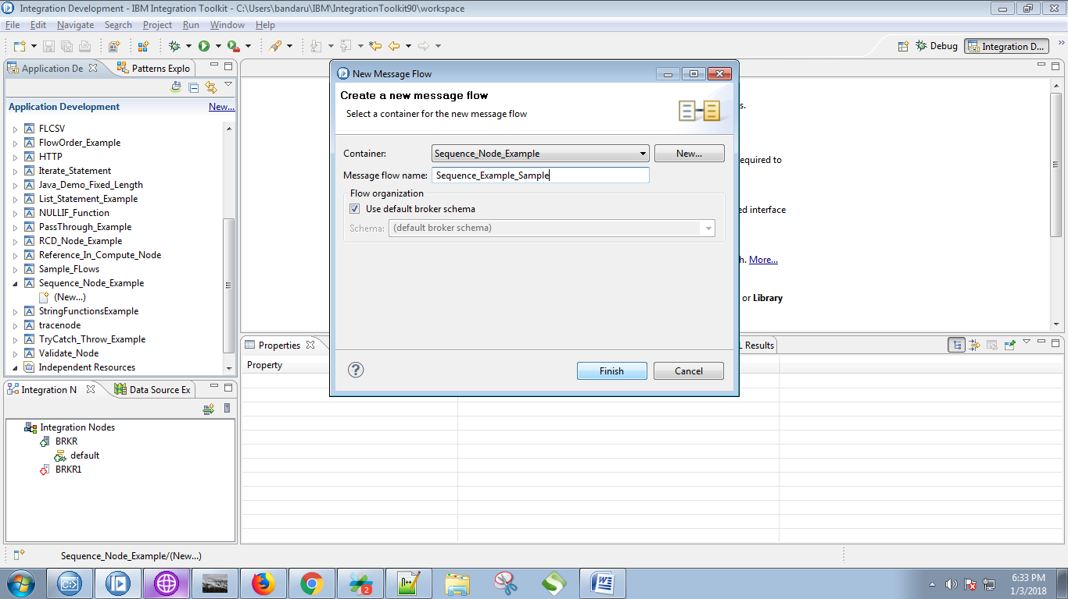

6. Drag the "MQInput" from "WebSphere MQ" section and name it.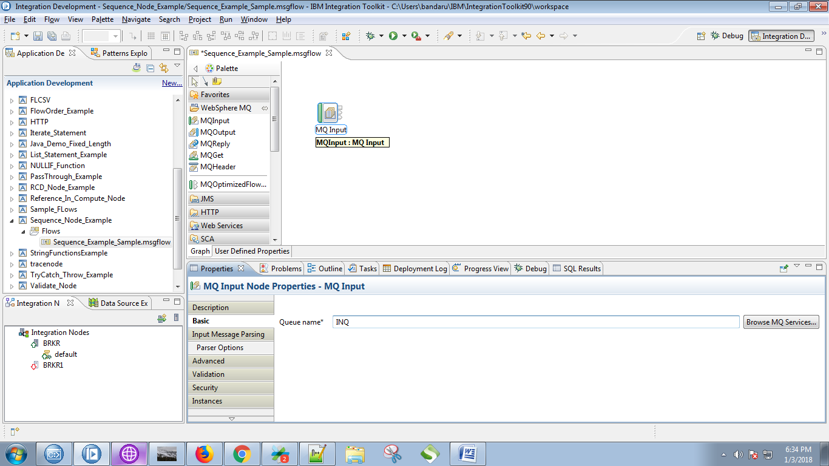

7. Select "XMLNSC" ans message domain.

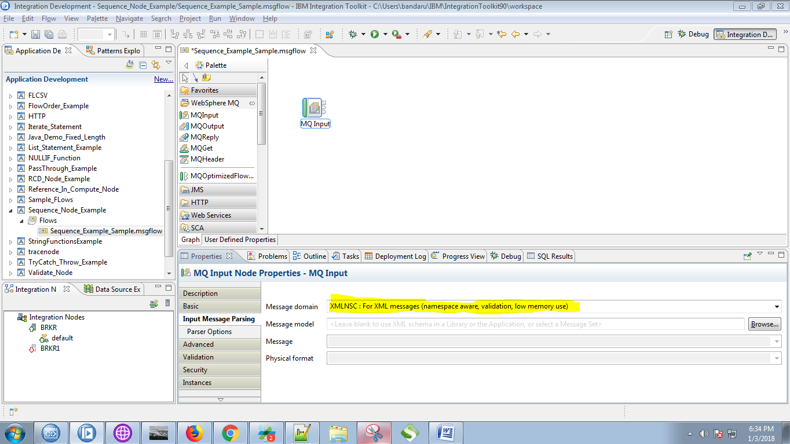

8. Drag the "Sequence" node from the "Route" section as in below fig.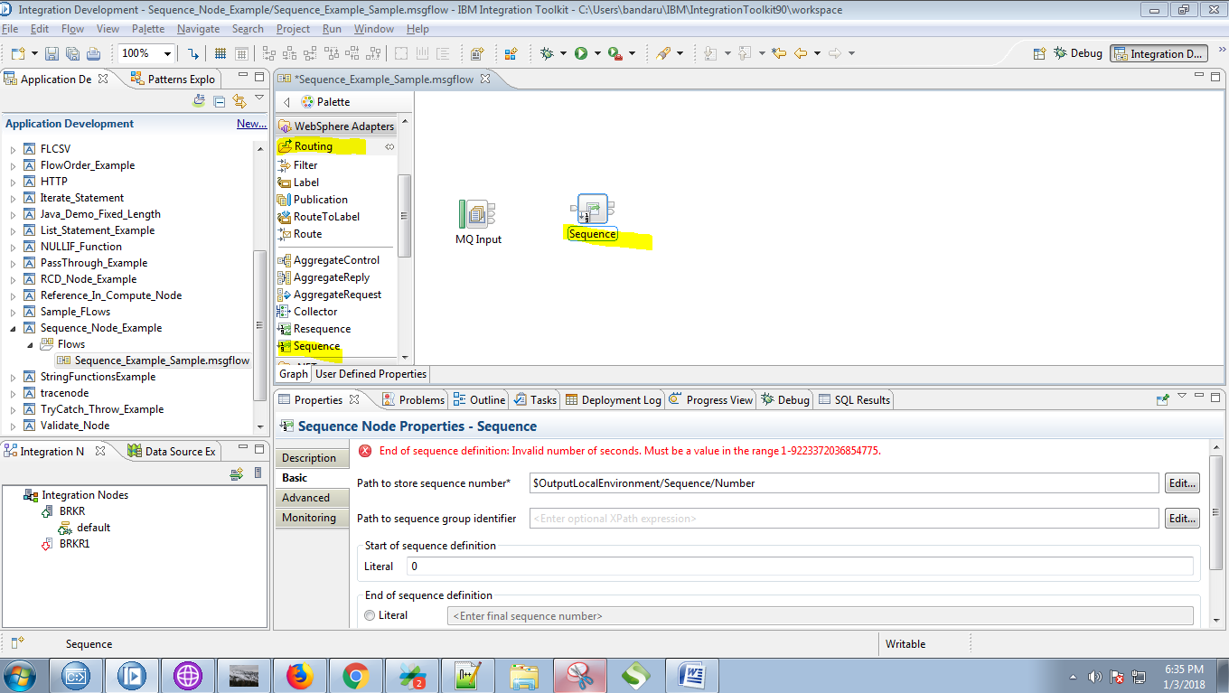

9. You can give any path (here i want to get sequence number in Output so i gave as OutputBody) and give a number of your choice in "Start of sequence definition" textbox.

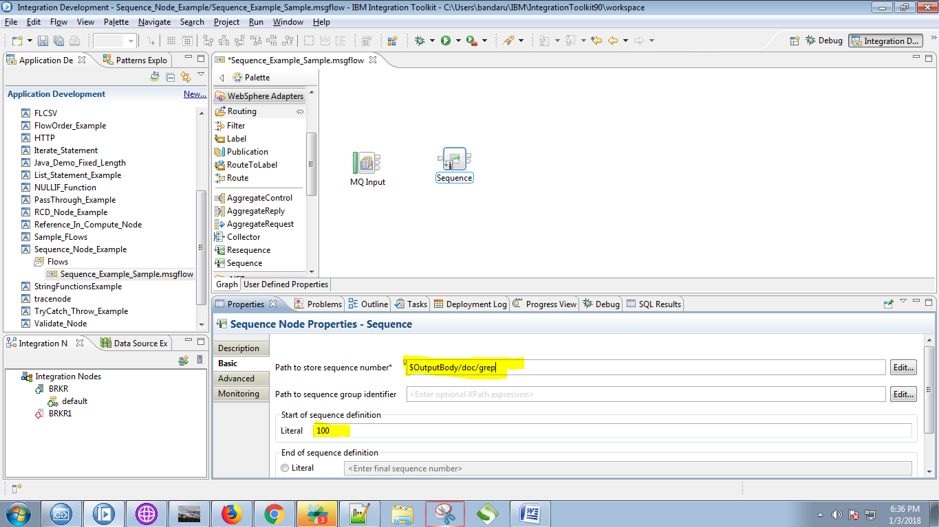

10. Give any number (which is in seconds) under "End of sequence definition" textbox.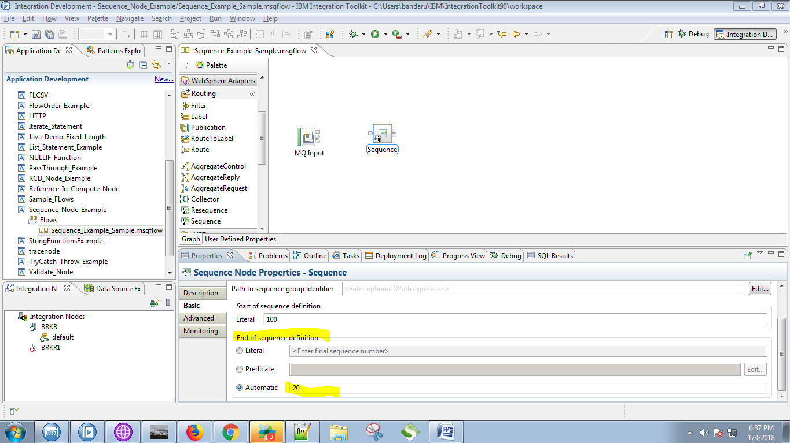

11. Connect "output" terminal of the MQInput with the "input" terminal of the Sequence node.

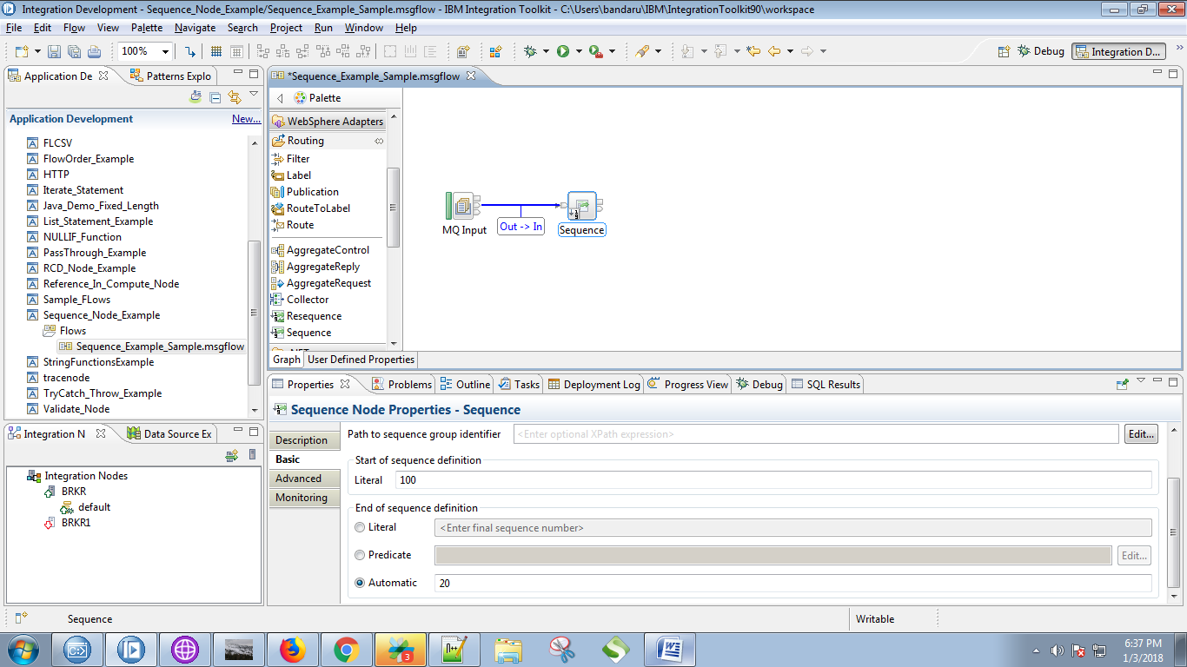

12. Drag the "compute" node from the "Transformation" section.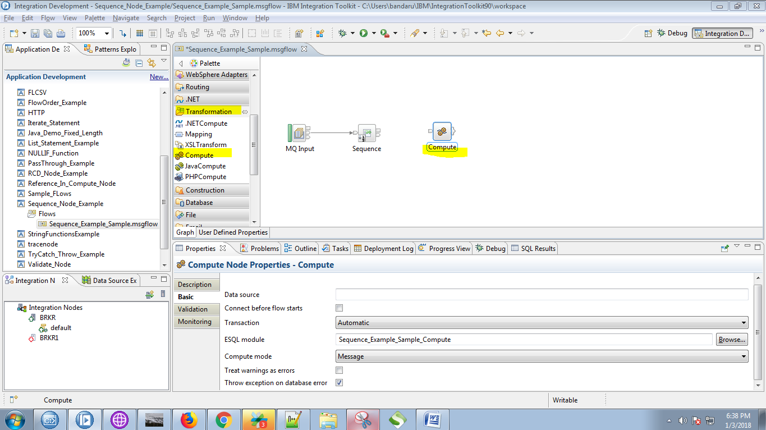

13. Connect "output" terminal of the sequence node with "input" terminal of the compute node.

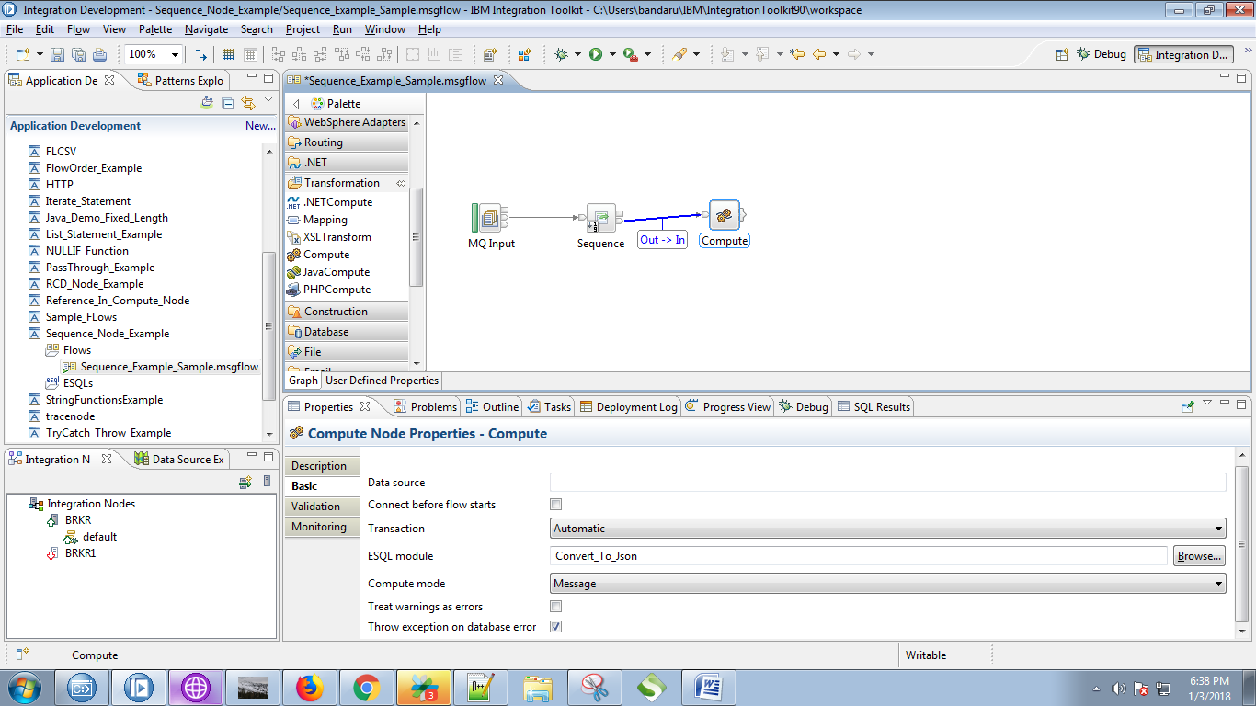

14. Drag the "MQOutput" from the "WebSphere MQ" and give it a name.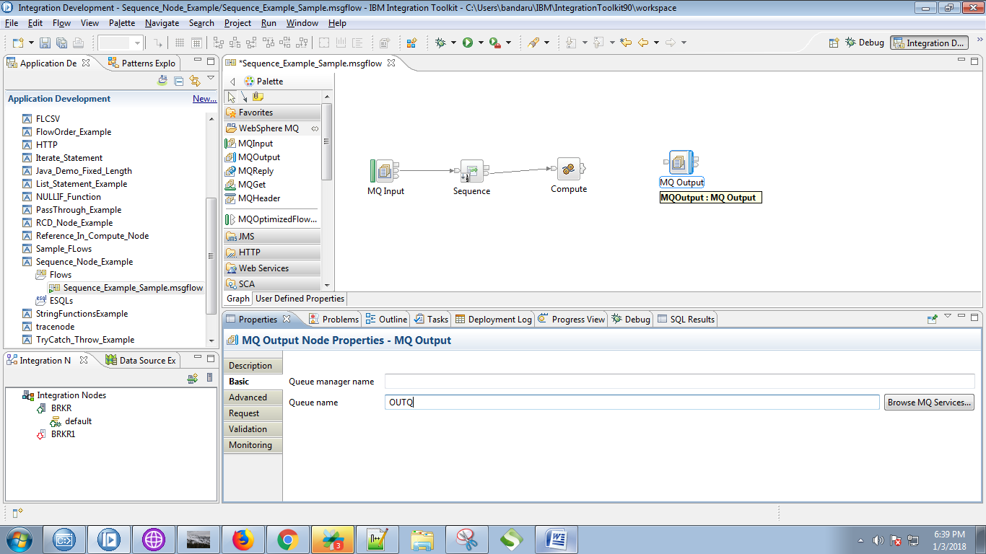

15. Click on output terminals of the compute node and select "Out" and click on "OK" button.

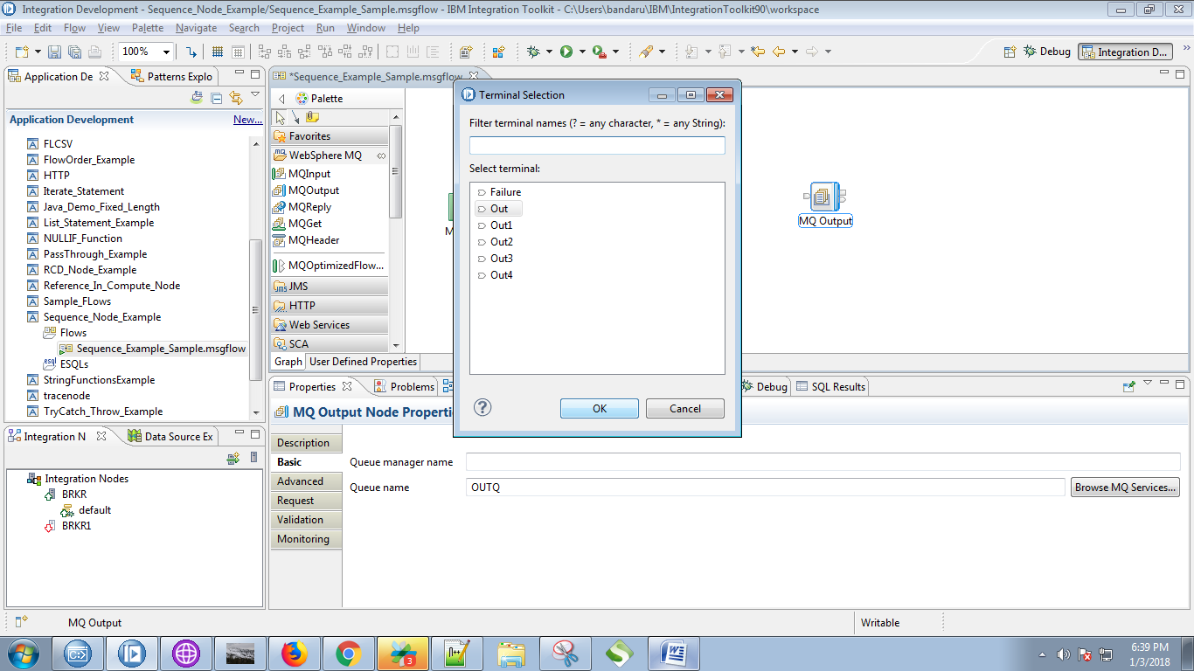

16. Connect "output" terminal of the compute node with "input" terminal of the MQOutput.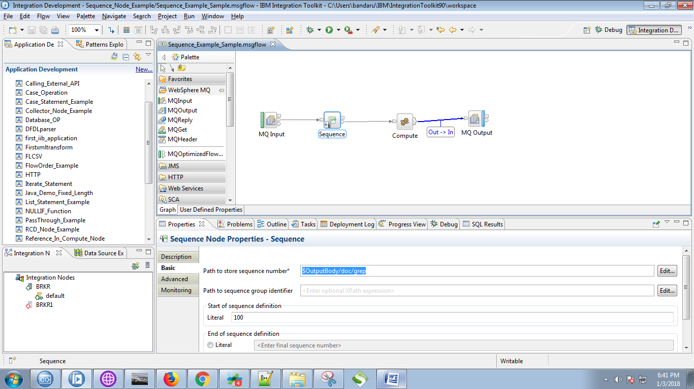

17. Double click on compute node and paste the following code.

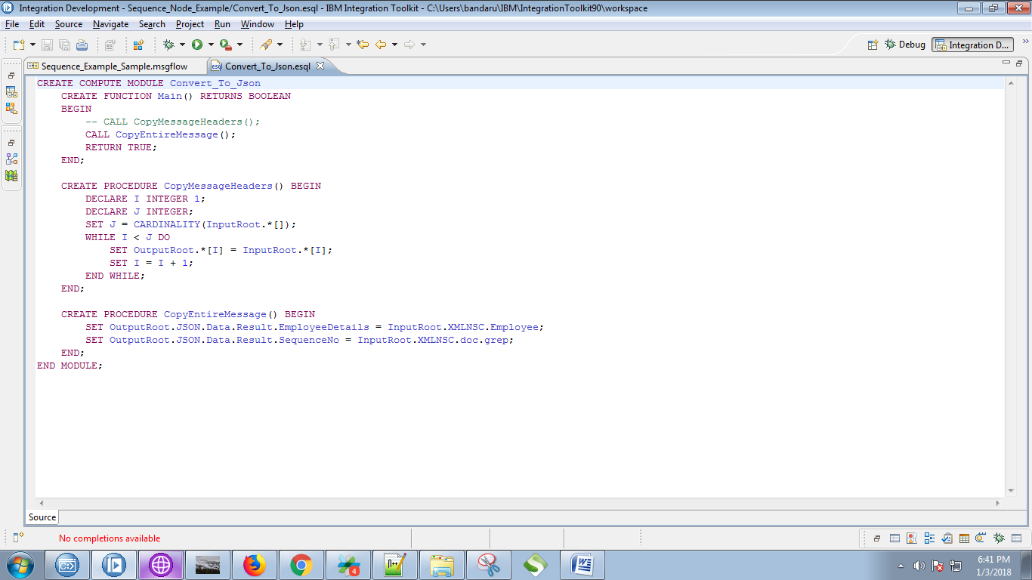

18. Create respective queues in WebSphere MQ Explorer.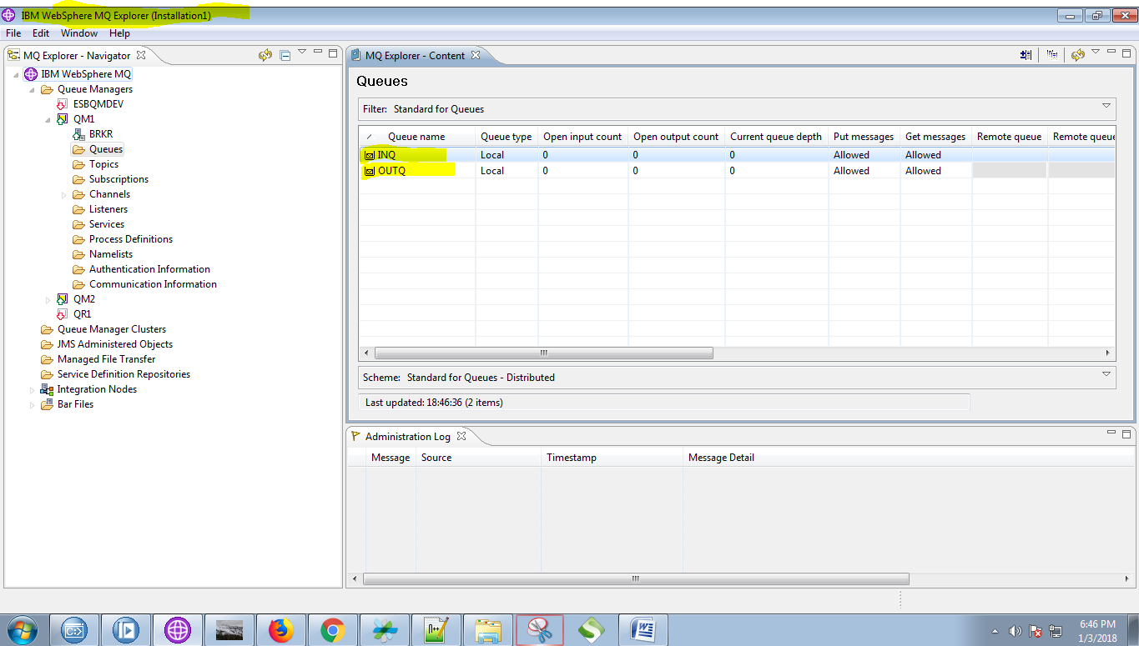

19. Right click on application and select "Deploy".

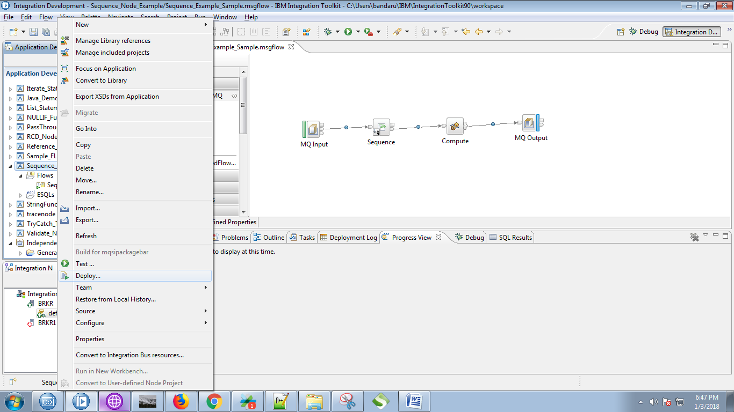

20. Select your running broker and execution group and click on "Finish" button.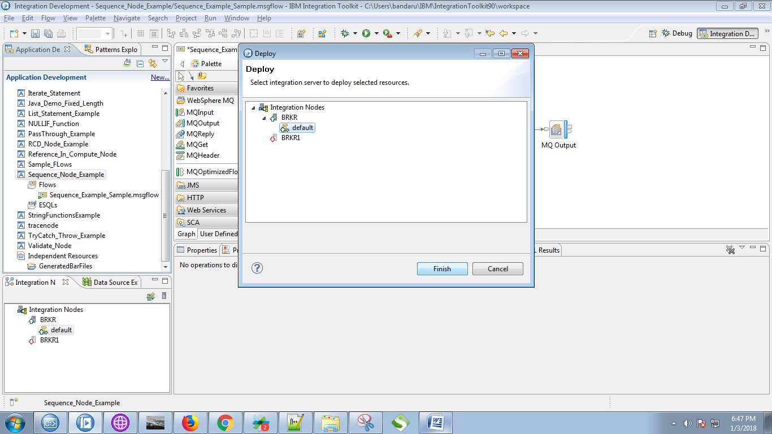

21. Open RFHUtil and select input queue.

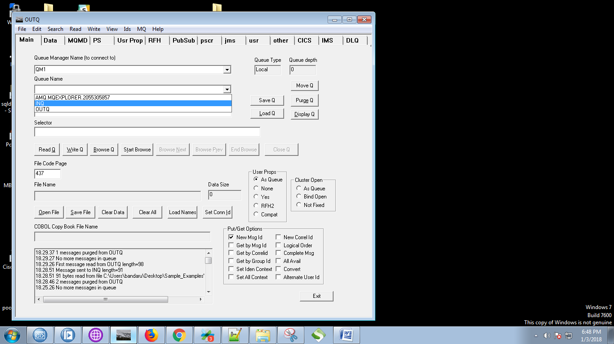

22. Click on "Open File" and select your input queue.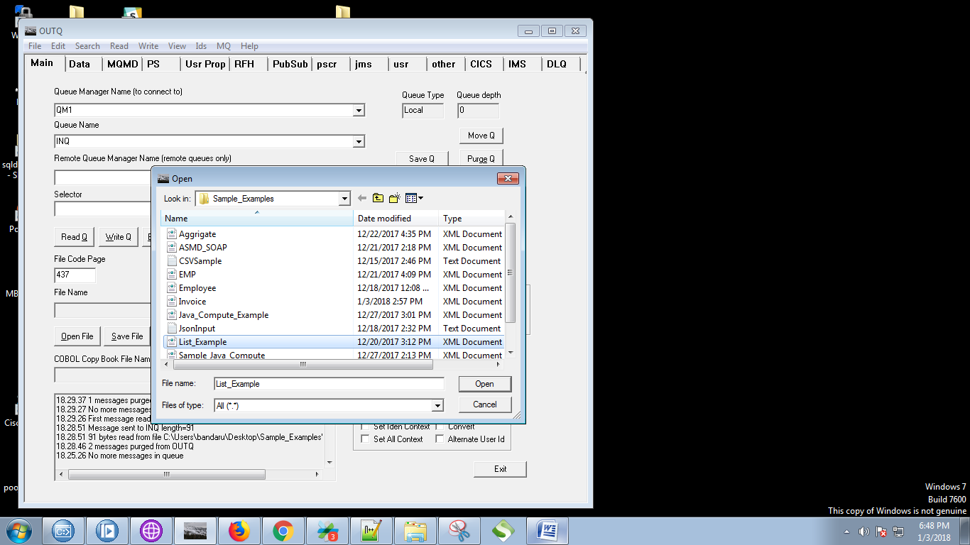

23. Now hit "Write Q" button.

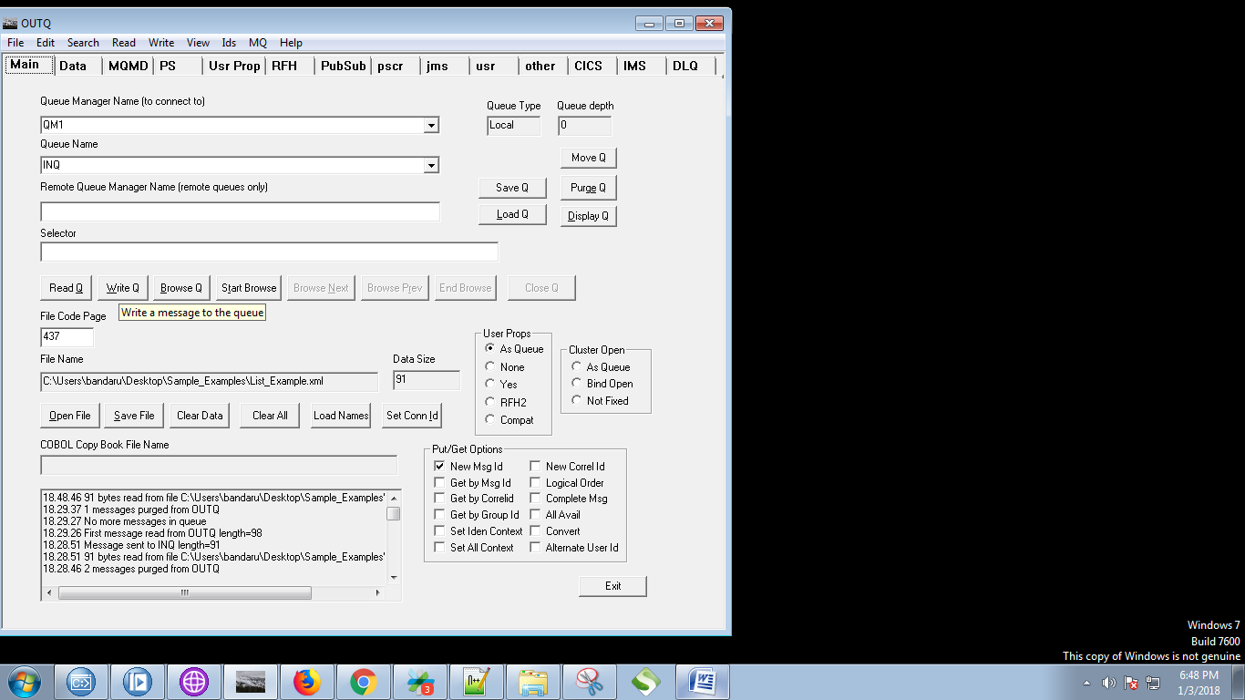

24. Our sample input file contains following data.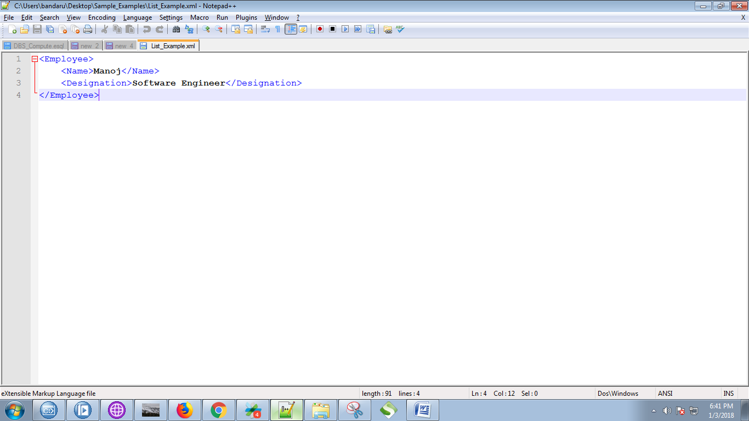

25. You can see output of the sequence node in below fig.

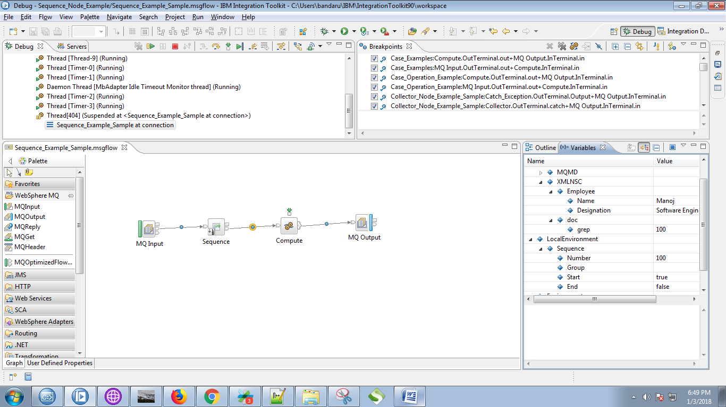

26. Output after the compute node.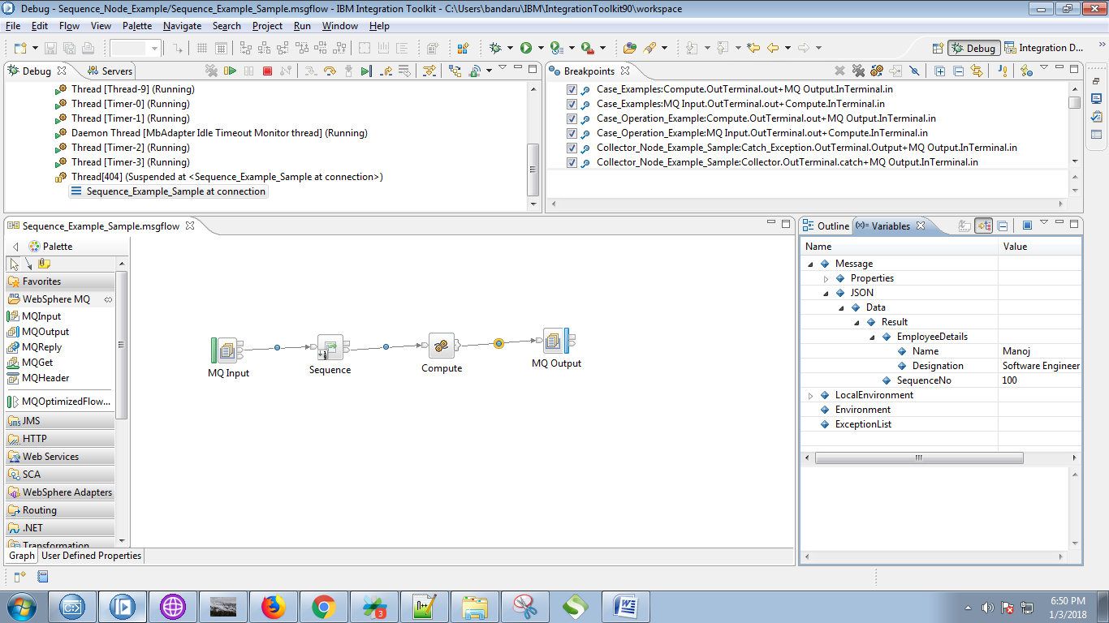

27. Now select output queue.

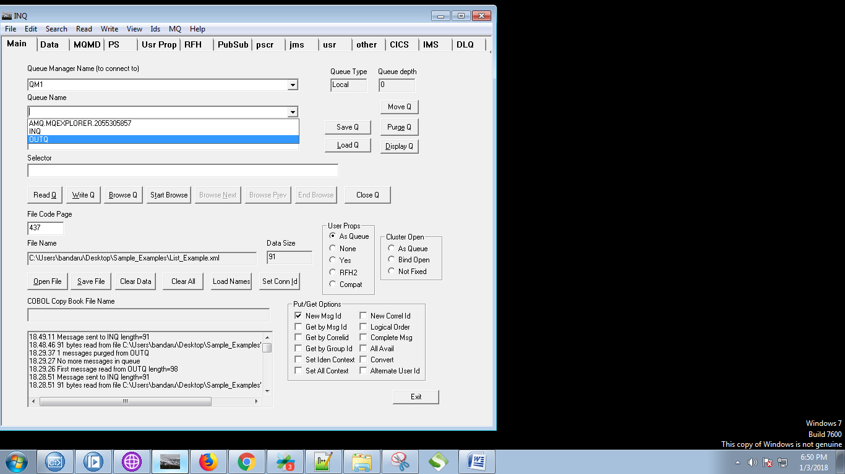

28. Hit "Browse Q" button.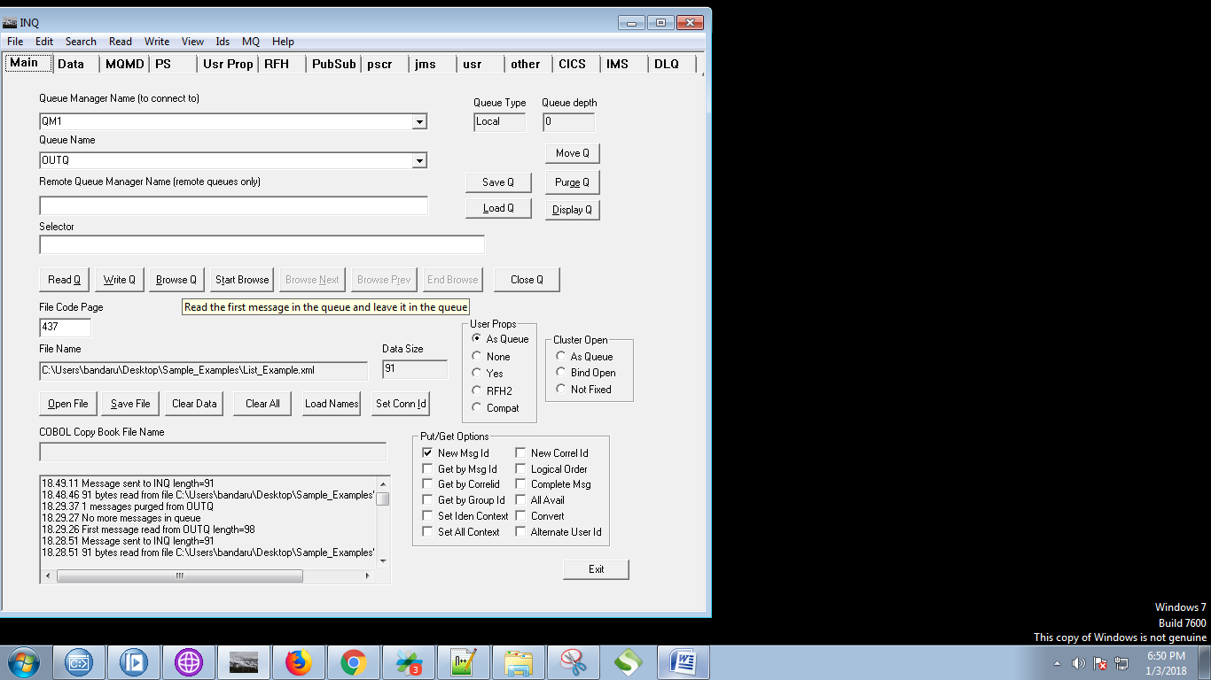

29. Your output can be seen under "Data" tab of RFHUtil.

